Predicting Emission Energy in Quasi-2D Perovskite LEDs from Spacer Chemistry and Precursor Stoichiometry: When Machine Learning Works, and When It Does Not

1. Introduction
Metal halide perovskites have attracted attention in the field of optoelectronics for their exceptional absorption coefficients, tunable band gaps, high colour purity, and solution-processability, enabling rapid progress in solar cells, photodetectors, lasers, and light-emitting diodes (LEDs).[1-5] Among low-dimensional variants, layered quasi-two-dimensional (quasi-2D) metal-halide perovskites have emerged as a versatile material for perovskite LEDs (PeLEDs).[6-10] Structurally, quasi-2D perovskite materials are formed by intercalating bulky organic spacer cations into the 3D framework, which slices the inorganic octahedra into layers of thickness n. These quasi-2D perovskite are primarily categorized into Ruddlesden–Popper (RP) phases with the general formula L₂A_{n-1}Pb_{n}X_{3n+1} (A = small organic cation or inorganic cation, X = halide ion) where monovalent spacer cations (L) form van der Waals gaps between the inorganic layers and Dion–Jacobson (DJ) phases with general formula L′A_{n-1}Pb_{n}X_{3n+1} where divalent diammonium cations (L′) bond directly to adjacent inorganic sheets eliminating the van der Waals gap. By tuning their quantum and dielectric confinements, halide composition, and organic spacer chemistry, we can cover a wide portion of the visible spectrum while retaining solution processability and improved environmental stability relative to their three-dimensional counterparts.[5, 11]
Since the parameter space is large in Quasi-2D perovskites, unlike their 3D counterparts, and the outcome is not always predictable from main stoichiometry alone, research groups struggle to explore this space experimentally, one combination at a time. Traditional materials development for perovskite optoelectronics has always depended on trial-and-error experimentation, density functional theory (DFT) and high-throughput screening. Now, Machine Learning (ML), which relies on statistical models, has emerged as a complementary fourth paradigm that can learn patterns from curated datasets, reduce experimental waste, and is not limited by the theoretical rules/laws as physical models like DFT, which enlarges the scope for finding new relations and empirical laws. Therefore, ML models have been adopted in perovskite photovoltaics and, more recently, in LED work, to extract patterns from curated datasets.[12-17]
Materials-focused ML workflows typically comprise data collection, data cleaning, feature engineering (molecular descriptor generation, correlation filtering, and feature selection), model training, and performance evaluation, along with insights from interpretability tools such as SHAP (Shapley Additive exPlanations) to connect predictions with physicochemical drivers.[17-20] In general, data-driven ML studies on perovskite optoelectronics focus on active-layer optimisation, transport-layer selection, interface engineering, and mechanism elucidation. To date, there are very few ML-based reports focused on the emission of quasi-2D perovskites and LEDs. Prior work on quasi-2D perovskites demonstrated that photon energy can be estimated from precursor composition and lipophilicity (XLogP3) of organic ligand, leveraging a random-forest model with root-mean-square errors on the order of ~0.05 eV. [21] Work on PeLED additives reached good accuracy only when the dataset was built from a single device architecture.[22] However, several gaps persist relative to the needs of quasi-2D LED researchers working across full visible-range color tuning. Our objective is to address the pain point where published ML studies are confined to a narrow spectral window (for example, green or blue Br/Cl systems) or a reduced feature set based solely on precursor ion ratios limited to single organic ligand systems, without explicitly encoding primary and secondary organic spacer structures through cheminformatics descriptors. In addition, we tried to answer whether external quantum efficiency (EQE) can be predicted with comparable confidence to the literature data available under the same curation rules.
Figure 1.
Figure 1 (to be inserted): Workflow from literature extraction to predicted Eph—SMILES conversion, AddHs descriptor calculation, correlation pruning, parallel RFECV (31 features) and SelectFromModel (13 features), tuned regressors, and SHAP readout.
In this work, we built ML models that address the above-mentioned gaps, leveraging a literature-extracted dataset of quasi-2D perovskites for training and testing. Herein, we built two primary sets of ML models: one targeting emission energy (eV) or wavelength (nm) forecasts, which are material’s intrinsic properties, and the other targeting EQE, which is a device-based metric. After preparing the first version of the dataset, we performed initial cleanup and formatting in the Snowflake data warehouse (Enterprise data warehouse) using Structured Query Language (SQL). Datasets are available on the GitHub account for reference. Thereafter, on top of the resulting dataset in Snowflake, the remaining data engineering operations were performed in Python (Jupyter Notebook) using the pandas library and dataframes. Thereafter, Simplified Molecular Input Line Entry System (SMILES) strings were generated programmatically for each organic ligand from its IUPAC name using the Chemical Identifier Resolver API hosted by the National Cancer Institute Computer-Aided Drug Design Group (nih.gov). Then, two-dimensional molecular descriptors per spacer (Primary and secondary) were generated using RDKit library structures (Chem.AddHs) using the SMILES. After generating molecular descriptors, high-dimensional feature extraction produced a dataset in which the number of features exceeded the number of observations, leading to the curse of dimensionality. So, to handle the curse of dimensionality, we applied a couple of feature elimination techniques in a sequential order: 1) Pairwise Pearson correlation and 2a) SelectFromModel for one set of models and 2b) Recursive Feature Elimination using Cross Validation (RFECV) for another set of models. After the model training and evaluation, we further performed an in-depth SHAP analysis. Figure 1 gives the holistic view of the workflow. All the codes for building different models and datasets are available on GitHub.
2. Results and Discussion

2.1. ML models for forecasting emission energies
To target emission energy forecasting, we prepared a curated dataset of 283 records for ML model training and testing, extracted from the available literature (dataset available on GitHub: SF_DATA_EMISSION_PEAK.xlsx, sheet SF_DATA_EMISSION_PEAK_NEW; Dataset Statistics are provided in SI Section S1). As the objective of the work is to build an efficient ML model that covers a wide range of emission photon energies (E_{ph}) forecasting in the visible region, the reports that provided the data points over photon energies between 1.53 and 3.06 eV, corresponding to a peak wavelength range of 405–810 nm, were collected. As expected, the data distribution is uneven, mirroring the available literature to date. About ≈ 69% of 283 records fall between 480 nm and 550 nm (green–yellow), ≈ 12% lie in the violet/blue (400–480 nm), and ≈ 17% in deep red and near-infrared (650–900 nm), with fewer orange/red points in between (SI Table S1.1). A model trained only on typical green recipes would underrepresent the halide and confinement extremes, thereby limiting its scope to the entire visible spectrum.
Figure 2: a) Correlation heatmap and b) feature importance scores for the 31 retained training features by the RFECV technique.
For the features, after generating two-dimensional molecular descriptors, as mentioned in the above section, the dataset had 462 columns, including compositional and halide flags, one-hot-encoded solvent columns, and Pri/Sec-prefixed RDKit descriptors organic spacers (217 descriptors for each). To maintain proper data distribution across reports with mixed organic spacers and single organic spacers, where 46 entries (~16%) are mixed primary and secondary spacers, we have used an 80/20 split stratified on the IS_MIXED_SPACERS_SPACER column, yielding 226 training and 57 test records. It is worth mentioning that mixed spacer formulations are chemically significant as the secondary ligand prominently impacts interlayer spacing and can determine which n domains contribute more to the emission. After splitting the dataset into a training and a test set, we began feature elimination to prevent the curse of dimensionality using only the training dataset, to avoid test data leakage. Initially, a Pairwise Pearson correlation was applied to the training fold with a Pearson correlation coefficient threshold of 0.9 (|r| > 0.90), and 173 redundant columns were omitted, leaving 289 candidates for selection. Starting from 289 post-correlation-based columns elimination, we applied RFECV and scikit-learn’s SelectFromModel in parallel, each fit on the 226 training records. RFECV ran a random forest regressor (max_depth = 5, min_samples_leaf = 6) with 5-fold stratified cross-validation. In this approach, features are removed one at a time until the cross-validated root mean square error (RMSE) of E_{ph} reaches a minimum. According to RFECV, the curve in Figure S1 shows that 31 of 289 features are optimal, as additional features stopped improving cross-validation. The correlation heatmap and the feature importance scores for the 31 features are shown in Figure 2. On the other hand, the SelectFromModel approach works differently. In this, a single random forest with threshold='mean' was fit on all 289 features, which means it keeps only descriptors whose impurity-based importance exceeds the forest average. Given the aggressive approach, we were left with only 13 features. The correlation heatmap and the feature importance scores for the 13 features are shown in Figure 3.
Figure 3: a) Correlation heatmap and b) feature importance scores for the 13 retained training features by the SelectFromModel technique.

Finally, multiple ML models (Regressors: random forest, CatBoost, XGBoost, Support Vector Regression (SVR), and Gaussian process) were built using the above prepared datasets. Among the models, the SVR model outperformed the others in forecasting emission energies using the dataset from the SelectFromModel approach. It is worth noting that the models built on the datasets using the RFECV technique also performed well. We have summarised all the models' performance in Table 1. Every regressor in Table 1 was tuned by randomised search (15 trials, five-fold cross-validation on the training set) before a single evaluation on the test fold. Tree ensembles can memorise rare spacer–halide combinations in 226 rows, and Gaussian Process Regressors (GPR) are sensitive to kernel length scales when the number of features (p) is large. For the thirty-one-feature RFECV matrix, tuning improved GPR’s coefficient of determination (R²) from 0.877 to 0.920, and in the case of thirteen-feature SelectFromModel matrix, SVR and GPR were improved, out of which SVR with a radial-basis-function kernel (SVR–RBF) emerged as the best, with the highest R² (eq. 1), least root mean square error (RMSE) (eq. 2) and mean absolute error (MAE) (eq. 3). Formulas for each evaluation metric are defined below, where E is reported photon energy, Ê is the predicted photon energy by the model, Ē is mean of reported photon energies.
$R² = 1 - [ Σᵢ (Eᵢ - Êᵢ)² ] / [ Σᵢ (Eᵢ - Ē)² ]$ – Equation 1
$RMSE = √[ (1/n) · Σᵢ (Eᵢ - Êᵢ)² ]$ – Equation 2
$MAE = (1/n) · Σᵢ |Eᵢ - Êᵢ|$ – Equation 3
It is crucial to understand that RFECV selects 31 features and achieves a lower training-fold cross-validation error than the 13-feature SelectFromModel channel, yet on test data, the 13-variable SVR is unambiguously better. It is worth mentioning that R² rose from 0.920 to 0.953, and RMSE fell from 0.097 to 0.074 eV, a 24% reduction in root error at less than half the dimensionality. The performance difference between RFECV and SelectFromModel aligns well with the sample-to-feature ratio, which influences overfitting. For 226 training points, the sample-to-feature ratio is 17.4 for the SelectFromModel set but only 7.3 for the RFECV set; therefore, the RFECV flow is more prone to overfitting, which works well on the training data but poorly on the test data.
Table 1. Summary of the hyperparameter-tuned models' performance in predicting the E_{ph}.
Feature selection | p | Model | R² | RMSE (eV) | MAE (eV)
SelectFromModel | 13 | SVR (RBF) | 0.953 | 0.074 | 0.048
SelectFromModel | 13 | Gaussian process | 0.920 | 0.096 | 0.061
SelectFromModel | 13 | CatBoost | 0.875 | 0.121 | 0.063
RFECV | 31 | SVR (RBF) | 0.920 | 0.097 | 0.054
RFECV | 31 | Gaussian process | 0.877 | 0.120 | 0.073
RFECV | 31 | CatBoost | 0.862 | 0.127 | 0.066
Apparently, the SelectFromModel based features list is short enough to derive scientific insights rather than a black-box vector (full names in SI Table S4; correlation structure and feature importances in Figure 3). The list consists of CL_PRIMARY_ORGANIC_HALIDE, BR_PRIMARY_ORGANIC_HALIDE, SPACER_TO_PB_RATIO, PbCl₂, PbBr₂, CsBr_TO_Pb, CsI_TO_Pb, FABr_TO_Pb, FAI_TO_Pb, SOLVENT_DMF, Pri_VSA_EState4, Sec_HallKierAlpha, Sec_PEOE_VSA6.
The halide flags that are based on the anion part of salts, sourcing the organic cation (CL_PRIMARY_ORGANIC_HALIDE, BR_PRIMARY_ORGANIC_HALIDE) and the inorganic lead-halide fractions (PbCl₂, PbBr₂) jointly determine the perovskite inorganic framework’s band edge and the halide chemical potential in the perovskite precursor. They do not, by themselves, specify a single n-phase, but they bias the average inorganic bandgap. Bromide-rich precursors generally favour hypsochromic shift, whereas chloride can raise energy further, but often complicates phase purity if not balanced with stoichiometry. On the other hand, iodide-rich recipes promote bathochromic shift. The model selected these features over dozens of unused RDKit columns, indicating a well-established relationship between halide chemistry and emission energy in perovskites.[5, 12] SPACER_TO_PB_RATIO is a critical parameter that controls the average n (number of layers in the inorganic framework) in quasi-2D perovskites. A greater spacer-to-lead ratio increases the organic fraction in the film, thereby strengthening the average dielectric confinement. It fosters the dominant transition to higher E_{ph} by shifting holistically towards lower n.[1] SPACER_TO_PB_RATIO survival after aggressive selection elimination is perhaps the strongest sanity check on the ML pipeline learning on confinement physics. The A-site cation to Pb ratios (CsBr_TO_Pb, CsI_TO_Pb, FABr_TO_Pb, FAI_TO_Pb) reflect the extent of diversity hidden in the A-site cation data in the prepared dataset. Our model does not assume a single cation; it learned from the blended ratios actually reported. SOLVENT_DMF surviving selection is not surprising as DMF and DMSO are known to change Pb coordination and crystallization kinetics, which in turn changes n partitioning. That variable is a processing fingerprint no less than a compositional one. Among molecular descriptors, Pri_VSA_EState4 (Surface-area + electrotopological-state) captures how much of the primary spacer’s van der Waals surface sits in a particular electronic-state bin, related to heteroatom content and polarizability at the organic–inorganic interface. For the 46 mixed-spacer entries, the features that survived elimination are Sec_HallKierAlpha, which refers to the flexibility/topology of the secondary amine and Sec_PEOE_VSA6, which refers to partial-charge surface area on the secondary ligand. They capture how a second ligand perturbs interlayer spacing and local dielectric environment without requiring an explicit n-distribution label. If hydrogens are omitted before RDKit featurization, the secondary term switches to Sec_EState_VSA8, while compositional inputs remain unchanged (SI Section S3), a small but reproducible sign that protonation state matters for secondary-spacer indices.
The 31-variable RFECV set adds, among others, PRIMARY_SPACER_FRACTION, SOLVENT_DMSO, several Pri_BCUT2D_* partitions, Pri_qed, rotatable-bond counts, and additional PEOE/VSA terms (full list, SI Table S4). They refined the picture but did not improve the test error, given the available sample size.
SHAP analysis
In this work, we leveraged SHAP to assess the impact of each feature on the model's behaviour. It provides validation that the fitted SVR ranks drivers in the same order as expected based on chemical mechanisms and confinement physics (Figure 4). For each test record, Shapley contributions (φ_{j}) decompose the prediction relative to the dataset’s target mean: a positive contribution from SPACER_TO_PB_RATIO, for example, indicates that a precursor stoichiometry that pushes the predicted E_{ph} above the database average, interpretable as stronger confinement for that entry. Tree-model SHAP on CatBoost shows the same qualitative ordering, with halide and stoichiometric terms first, and secondary-spacer descriptors active mainly on mixed-ligand rows (Figure Sx). A parity plot of measured versus predicted E_{ph} for the 57 test points (Figure 6), with symbols distinguishing mixed-spacer entries, is the natural companion figure for judging systematic bias at the spectral extremes.
To move from accurate prediction to actionable chemistry, we computed SHAP (SHapley Additive exPlanations) values.[12] For each record with feature vector x, the SVR prediction is decomposed as where φ0 is the baseline expectation over a reference background distribution (here, φ0 = 2.33 eV, from 50 randomly drawn training inks) and φj is the Shapley contribution of descriptor j. Positive φj pushes the prediction to higher Eph (bluer emission); negative φj pushes it to lower Eph (redder). Because SVR is not a tree model, we used Kernel SHAP with the fitted f(x), standardized features, 50 background samples, and 250 coalition samples per record; rankings are summarized over all 283 inks as the mean absolute contribution ⟨|φj|⟩.
Table 2 links these numerical rankings to quasi-2D photophysics. The “trend when feature increases” column reports the Pearson correlation between the raw feature value and φj across the corpus (positive ⇒ higher input ⇒ bluer prediction on average). This is observational, not causal—but the alignment with confinement and halide chemistry is strong.
Table 2. SHAP summary for tuned SVR–RBF (thirteen SelectFromModel features, AddHs). ⟨|φ|⟩ = mean absolute Shapley contribution (eV); share = percentage of Σ⟨|φj|⟩.
Rank | Descriptor | ⟨|φ|⟩ (eV) | Share (%) | Trend when feature ↑ | Chemical / physical mechanism
1 | PbBr2 | 0.074 | 21.4 | Bluer (r ≈ +0.95) | Inorganic Br raises the lead-halide bandgap and favours wider-gap, more confined wells; dominant lever on average emission colour.
2 | BR_PRIMARY_ORGANIC_HALIDE | 0.059 | 17.1 | Bluer (r ≈ +0.96) | Bromide on the primary ammonium spacer increases halide incorporation on the organic site and blue-shifts the emitting manifold relative to iodide-only inks.
3 | FAI_TO_Pb | 0.031 | 8.9 | Redder (r ≈ −0.98) | Formamidinium iodide fraction enriches iodide character and lowers the effective gap—consistent with red-shifted quasi-2D PL/EL when iodide dominates.
4 | FABr_TO_Pb | 0.028 | 8.0 | Redder (r ≈ −0.91) | FA bromide pathway competes with high-gap chloride/bromide routes; higher FA:Pb (Br) correlates with lower predicted Eph in this corpus.
5 | CsI_TO_Pb | 0.027 | 7.8 | Redder (r ≈ −0.87) | Cesium iodide supply biases films toward iodide-rich, lower-gap character relative to all-bromide precursor sets.
6 | PbCl2 | 0.027 | 7.7 | Bluer (r ≈ +0.97) | Chloride in the inorganic precursor raises chemical potential for wide-gap domains and correlates with higher reported Eph.
7 | Pri_VSA_EState4 | 0.024 | 6.8 | Redder (r ≈ −0.79) | Primary-spacer VSA by electrotopological state—proxy for heteroatom-rich headgroups that alter hydrogen bonding and interlayer spacing at the interface.
8 | CsBr_TO_Pb | 0.023 | 6.5 | Weak | CsBr fraction modulates A-site/halide balance; weaker monotonic trend because Cs appears with mixed halides across papers.
9 | SOLVENT_DMF | 0.017 | 4.9 | Weak | DMF vs DMSO shifts crystallization and phase distribution; survives selection because solvent is consistently reported.
10 | SPACER_TO_PB_RATIO | 0.013 | 3.7 | Weak | Nominal spacer:lead stoichiometry targets average n and dielectric confinement; smaller SHAP share because processing redistributes n after ink casting.
11 | Sec_HallKierAlpha | 0.011 | 3.3 | Weak | Secondary-spacer flexibility/topology (mixed-spacer rows); perturbs interlayer spacing and local dielectric environment.
12 | CL_PRIMARY_ORGANIC_HALIDE | 0.008 | 2.3 | Bluer (r ≈ +0.97) | Chloride on the primary spacer; high correlation but low ⟨|φ|⟩ because fewer entries use chloride-primary recipes.
13 | Sec_PEOE_VSA6 | 0.006 | 1.7 | Weak | Partial-charge-weighted VSA on the secondary ligand; fine-tunes mixed-spacer systems.

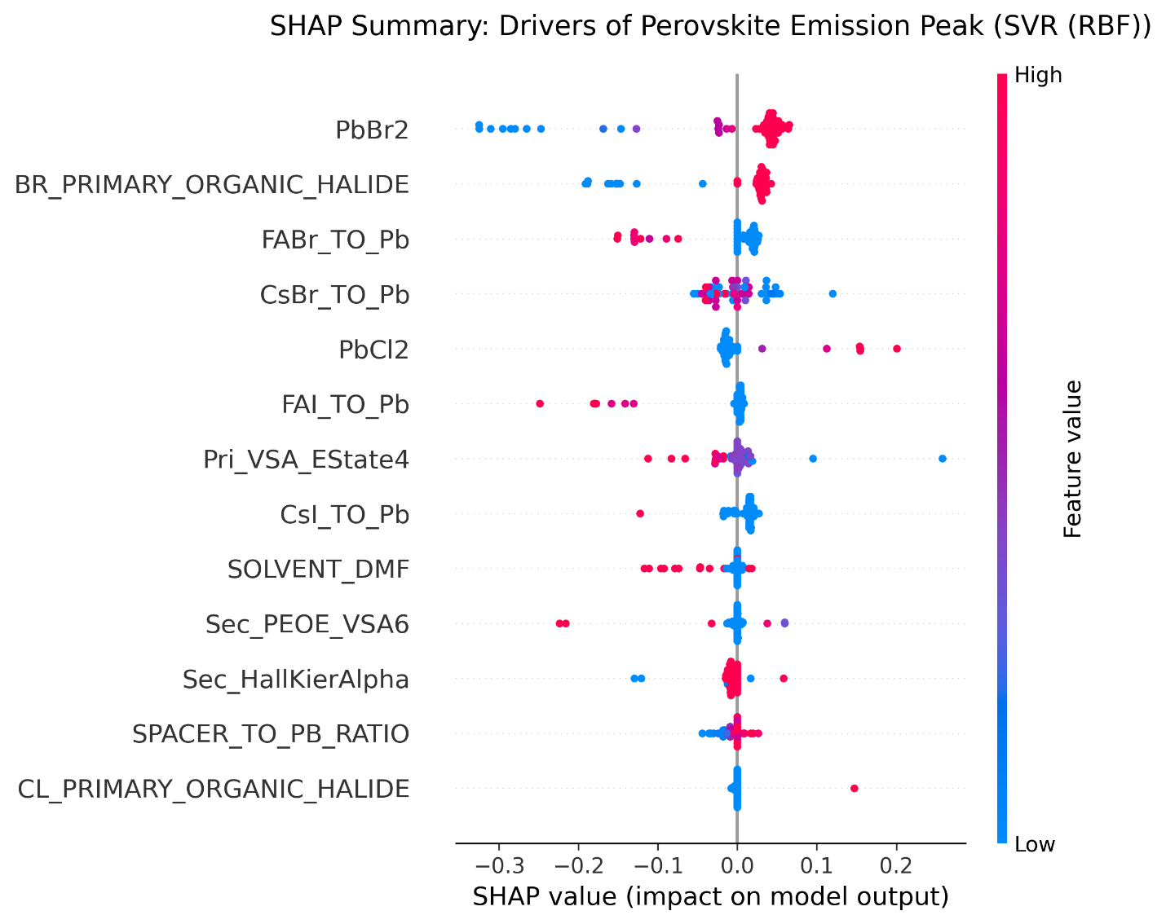
Figure 4: SHAP for the SVR champion model.

2.3. External quantum efficiency: a different problem
Similar to the emission energy forecasting model development discussed above, now to target predicting EQEs of the Quasi 2D PeLEDs, we prepared a curated dataset of 266 records extracted from the available literature (dataset available on GitHub: SF_DATA_EMISSION_PEAK.xlsx, sheet EQE_CLEANED) with hole-transport material (HTL), electron-transport material (ETL), additive, and experimental processing variables (temperature, annealing time) in addition to the compositional columns used for emission. Thirty-four distinct HTLs and thirteen ETLs are available in the dataset, while EQE spans 0.002% to 30.8%. After repeating the same workflow steps for featuring engineering used above for emission energy forecasting models, post-recursive feature elimination to 20 descriptors, and aggressive hyperparameter tuning, the best tree models achieved R² ≈ 0.44–0.51 on the test fold (Table 2). We developed a CatBoost model that treats HTL, ETL, and additive as native categorical variables to encode the proper device architecture, as reported in published papers—raised R² to 0.57 with RMSE ≈ 4.4% EQE. That improvement is real but modest, it explains a little more than half the variance in EQE whereas the emission model explains about ninety-five percent of the variance in photon energy on the same style of split and workflow with more details.
After achiving the best ML for predicting emission colour at the materials level, one might hope EQE would follow from the same tables. Apparently, it does happen, at least not with the fields available in published PeLED reports.
Table 2. Summary of the hyperparameter-tuned models' performance in predicting the EQE.
Model | R2 | RMSE (% EQE) | MAE (% EQE)
Tuned XGBoost (RFE, 20 features) | 0.512 | 5.01 | 3.77
Tuned random forest | 0.478 | 5.18 | 3.88
Tuned CatBoost | 0.443 | 5.35 | 3.75
CatBoost (architecture features) | 0.570 | 4.42 | 3.25
It is worth mentioning that the gap between the emission forecasting model (R2 ≈ 0.95) and the EQE forecasting model (R² ≈ 0.5–0.6) is not a failure of the algorithms. Rather, there are straightforward, concrete reasons that caused this issue. EQE couples radiative efficiency to charge-injection balance and outcoupling. Pinhole-free morphology, interfacial trap passivation, refractive-index matching and the exact measurement protocol (integrated sphere calibration, pixel area, sweep direction) move EQE by several percentage points without changing the precursor stoichiometry. Different laboratories also anneal and antisolvent-quench under conditions that are described in prose but rarely digitized. Zhang et al. illustrated that the data problem in device-targeted ML development persists even with careful molecular featurization. PeLED performance labels in the literature are sparse and heterogeneous, given the volume of available data. Therefore, we can expect good accuracy only when the dataset is built from a single device architecture and supplemented with in-house experiments, as fabrication conditions are consistent across devices.[22] This infers that models are most trustworthy when inputs and labels refer to the same experimental contract, and least trustworthy when they silently average over incompatible fabrication routes.
Figure 7 (to be inserted): Schematic separating compositional controls of Eph from morphological and interfacial controls of EQE.
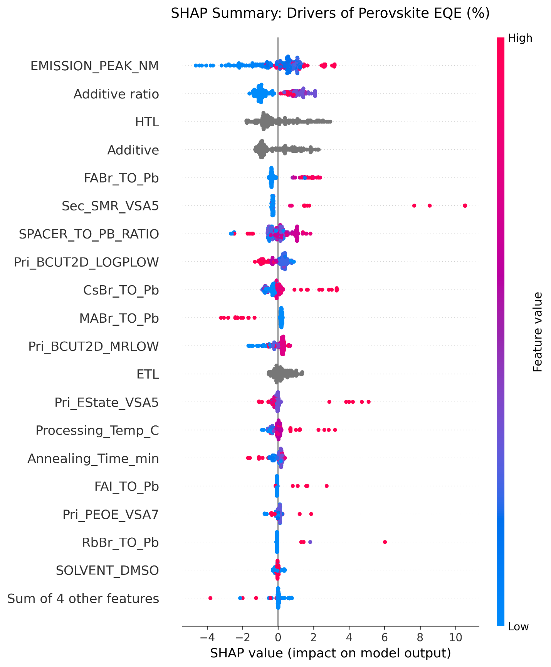
Figure 8: SHAP summary for the CatBoost architecture EQE model.

3. Conclusions
Literature ML can predict quasi-2D PeLED photon energy across a 405–810 nm compilation with useful accuracy if the descriptor set is kept chemically lean. In our hands, thirteen variables—halide identity, spacer-to-lead stoichiometry, key A-site and lead-halide fractions, DMF processing, and three spacer topology descriptors on hydrogen-complete structures—outperform a thirty-one-variable RFECV optimum on held-out data (R2 = 0.953 versus 0.920 for tuned SVR; RMSE 0.074 versus 0.097 eV). The result is consistent with a simple statistical fact: two hundred twenty-six training points cannot support three dozen free descriptor dimensions without overfitting, even when cross-validation suggests otherwise.
The selected features map cleanly onto confinement and composition arguments chemists already use to tune colour. SHAP analysis does not introduce contradictory rankings; halide and stoichiometry terms lead, with secondary-spacer indices appearing mainly where mixed ligands are present.
EQE, in contrast, is not predicted well from the same style of table (R2 roughly 0.5–0.6 at best). Transport-layer labels help modestly, but morphology and fabrication protocol dominate efficiency in ways literature columns do not capture. We would use the emission model to narrow spacer and ink choices before synthesis, and treat any EQE prediction as a weak prior until devices are built under a fixed stack and processing checklist.
Follow-up work in our group will hold out entire reference DOIs from training, link predictions to explicit n-phase indicators where XRD or optical data exist, and feed back in-house devices fabricated under constant HTL/ETL conditions to see whether EQE becomes learnable once the hidden variables are controlled.

Data Availability
Analysis code and configuration files are available at https://github.com/ranadeeprajsumukam/ML_Quasi_2D_Emission_EQE. The curated workbook is available from the corresponding author on reasonable request.

References
1. Hazra, V., A. Mandal, and S. Bhattacharyya, Optoelectronic insights of lead-free layered halide perovskites. Chemical Science, 2024. 15(20): p. 7374-7393.
2. Sumukam, R.R., et al., Halide Ions Distribution and Charge Dynamics in Mixed-Halide Perovskites. 2022. 16(5): p. 2100576.
3. Kumar, G.S., et al., Perovskite Nanowires for Next-Generation Optoelectronic Devices: Lab to Fab. ACS Applied Energy Materials, 2022. 5(2): p. 1342-1377.
4. Li, G., et al., Stabilizing high-efficiency perovskite solar cells via strategic interfacial contact engineering. Nature Photonics, 2026. 20(1): p. 55-62.
5. Karlsson, M., et al., Mixed halide perovskites for spectrally stable and high-efficiency blue light-emitting diodes. Nature Communications, 2021. 12(1): p. 361.
6. Kumar, G.S., R.R. Sumukam, and B. Murali, Quasi-2D perovskite emitters: a boon for efficient blue light-emitting diodes. Journal of Materials Chemistry C, 2020. 8(41): p. 14334-14347.
7. Zhang, J., et al., Modulations of Quasi-Two-Dimensional Metal Halide Perovskites toward High-Performance Blue Light-Emitting Diodes. Advanced Functional Materials, 2026. 36(22): p. 2509226.
8. Liu, Y., et al., High-Efficiency and Stable Pure Bromine Blue Light-Emitting Diodes Enabled by Hybrid Quasi-2D Perovskite. Advanced Functional Materials, 2026. 36(11): p. e15841.
9. Zhang, G., et al., Synergistic Passivation via Amino Acid Derivative for Highly Efficient Quasi-2D Perovskite Green Light-Emitting Diode. ACS Applied Materials & Interfaces, 2025. 17(20): p. 29864-29872.
10. Yu, A., et al., Promoting Phase Transition in Quasi-2D Perovskites For High-Performance Pure-Red LEDs. Advanced Materials, 2025. 37(28): p. 2503704.
11. Tsai, H., et al., High-efficiency two-dimensional Ruddlesden-Popper perovskite solar cells. Nature, 2016. 536(7616): p. 312-6.
12. Lu, F., et al., Machine learning for perovskite optoelectronics: a review. 2024. 6 %J Advanced Photonics(5): p. 054001.
13. de la Asunción-Nadal, V., et al., Machine learning for perovskite solar cells: a comprehensive review on opportunities and challenges for materials scientists. EES Solar, 2025. 1(6): p. 927-957.
14. Zhang, R., et al., Machine Learning Prediction of Organic–Inorganic Halide Perovskite Solar Cell Performance from Optical Properties. ACS Energy Letters, 2025. 10(4): p. 1714-1724.
15. Toprak, A., Predicting photovoltaic output parameters of perovskite solar cells using explainable machine learning with physics-informed and simulation-derived descriptors. Materials Today Communications, 2026. 52: p. 114968.
16. Wang, Z., et al., Data-Driven Design of Halide Perovskites for Efficient Green Light-Emitting Diodes via Machine Learning and DFT. The Journal of Physical Chemistry C, 2025. 129(30): p. 13542-13557.
17. Wang, S., et al., From Formability to Bandgap: Machine Learning Accelerates the Discovery and Application of Perovskite Materials. ACS Nano, 2025. 19(32): p. 29049-29072.
18. Wang, Y., et al., Recent advances in lead-free halide perovskites: from synthesis to applications. Journal of Materials Chemistry C, 2024. 12(28): p. 10267-10329.
19. Zhang, L., et al., Prediction of Operational Lifetime of Perovskite Light Emitting Diodes by Machine Learning. 2024. 6(6): p. 2300772.
20. Ghodeswar, U.S., et al., The optimization of design and performance in hybrid organic/inorganic LEDs toward next-generation high-efficiency LEDs: application of multi-model hybrid machine learning approach. Journal of Computational Electronics, 2025. 24(3): p. 92.
21. Wang, W., et al., Predicting the photon energy of quasi-2D lead halide perovskites from the precursor composition through machine learning. Nanoscale Advances, 2022. 4(6): p. 1632-1638.
22. Zhang, L., et al., Deep Learning for Additive Screening in Perovskite Light-Emitting Diodes. 2022. 61(37): p. e202209337.

